**Avocado Data Set Project-**

This data was downloaded from the Hass Avocado Board website in May of 2018 & compiled into a single CSV. Here’s how the Hass Avocado Board describes the data on their website:

The table below represents weekly 2018 retail scan data for National retail volume (units) and price. Retail scan data comes directly from retailers’ cash registers based on actual retail sales of Hass avocados. Starting in 2013, the table below reflects an expanded, multi-outlet retail data set. Multi-outlet reporting includes an aggregation of the following channels: grocery, mass, club, drug, dollar and military. The Average Price (of avocados) in the table reflects a per unit (per avocado) cost, even when multiple units (avocados) are sold in bags. The Product Lookup codes (PLU’s) in the table are only for Hass avocados. Other varieties of avocados (e.g. green skins) are not included in this table.

The avocado, a tree likely originating from south-central Mexico, is classified as a member of the flowering plant family Lauraceae. The fruit of the plant, also called an avocado, is botanically a large berry containing a single large seed.

***You can download the data set and code from this https://github.com/dsrscientist/Data-Science-ML-Capstone-Projects***

**Work Flow:**

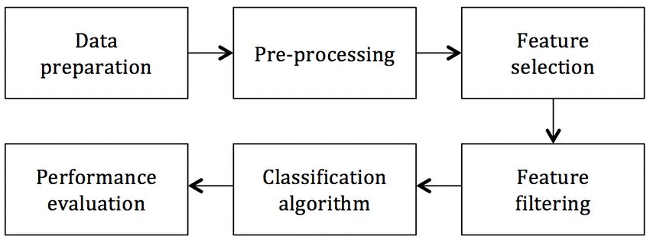

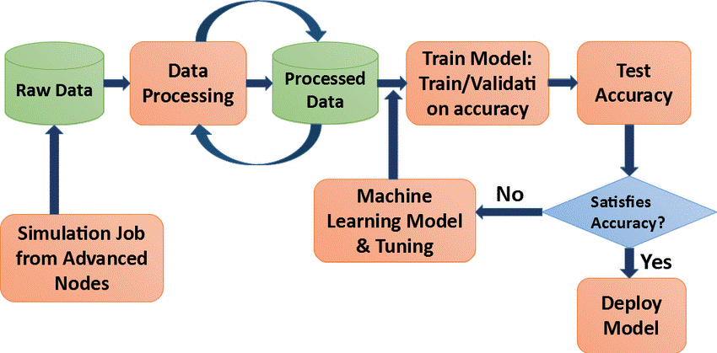

**Inspiration /Label**

The data set can be seen in two angles to find the city or region and find the average price. So, I will predict this data set in both ways.

**Fields/Columns:**

* Date — The date of the observation
* Average Price — the average price of a single avocado
* type — conventional or organic
* year — the year
* Region — the city or region of the observation
* Total Volume — Total number of avocados sold
* 4046 — Total number of avocados with PLU 4046 sold
* 4225 — Total number of avocados with PLU 4225 sold
* 4770 — Total number of avocados with PLU 4770 sold

**Problem description:**

The goal is to predict the average price which is continuous in nature of the different type of avocado and using the region that in which region they are lying.

**Importing Library:**

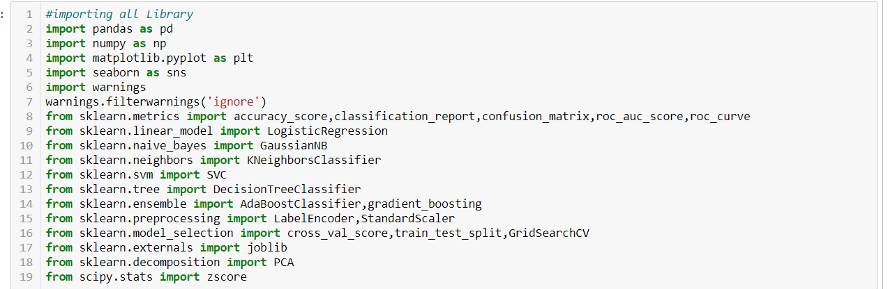

Fig 1

I am importing the all library which I required for EDA, visualization, prediction and finding all matrices. The reason of doing this is that it become easier to use all the import statement at one go and we do not require to import the statement again at each point. We could find all the importing statement at one place without finding it on whole notebook and can update also.

**Loading Data Set into variable:**

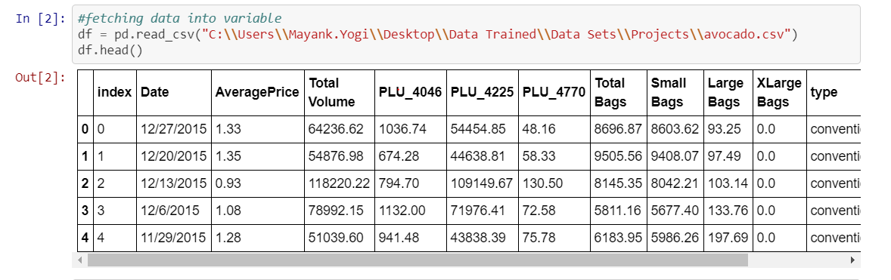

Fig 1

Here I am loading the data set into a variable i.e. “df” and processing the first 5 rows. As in this data set most of the column are float in nature and type and sex is of categorical value.

**Exploratory Data Analysis:**

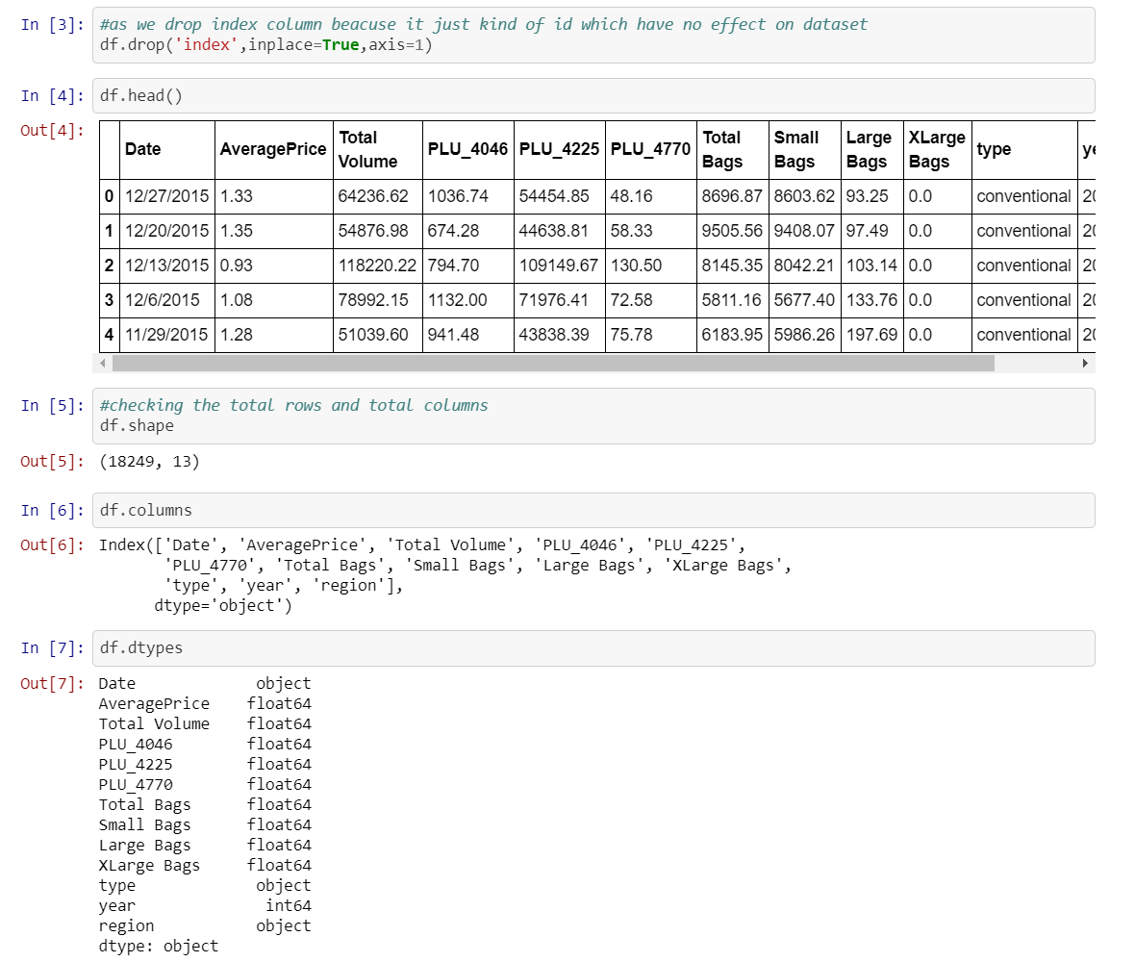

Fig 4

As seen in data set there is one index column which does not play any important role for prediction in the price of avocado, so I am dropping that column.

Also, I am checking the shape of the data set as there are 18249 rows and 13 columns after deleting the index column.

Also, most of the column are of same data type that is float and Date, type and region is of object data type.

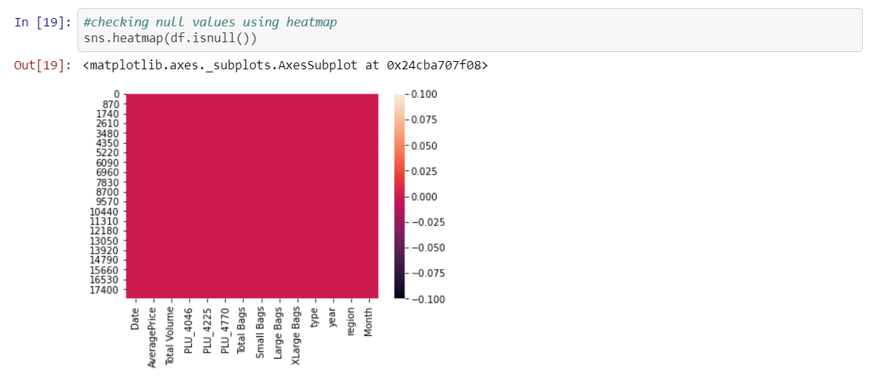

Fig 5

Above I am checking the null values, as find there are no null values in the data set because the red color is distributed equally correspond to each column.

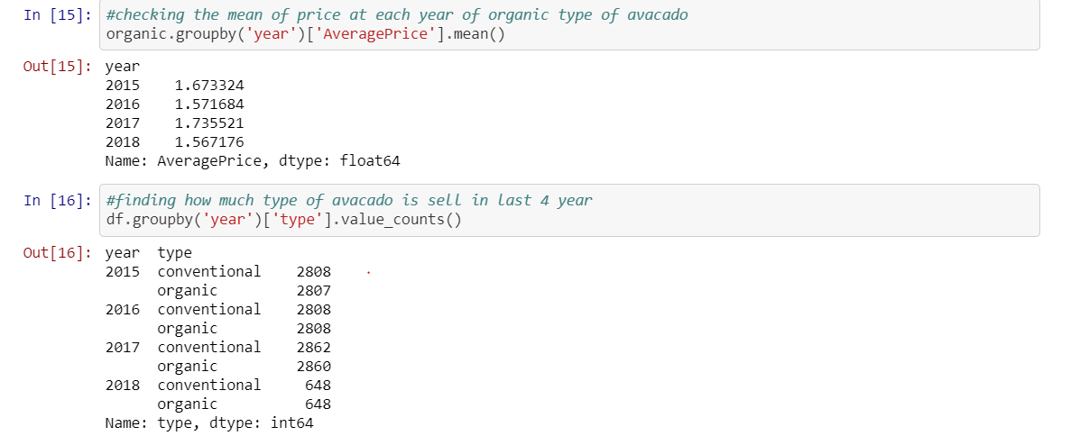

Fig 6

In above, I am finding that year 2017 is aggressive year where avocado price is higher as compared to other year and 2015 is at second number.

Also, I am finding that at each year present in the data set, which type of avocado is has total count, so both type of avocado is present almost in same amount in the data set.

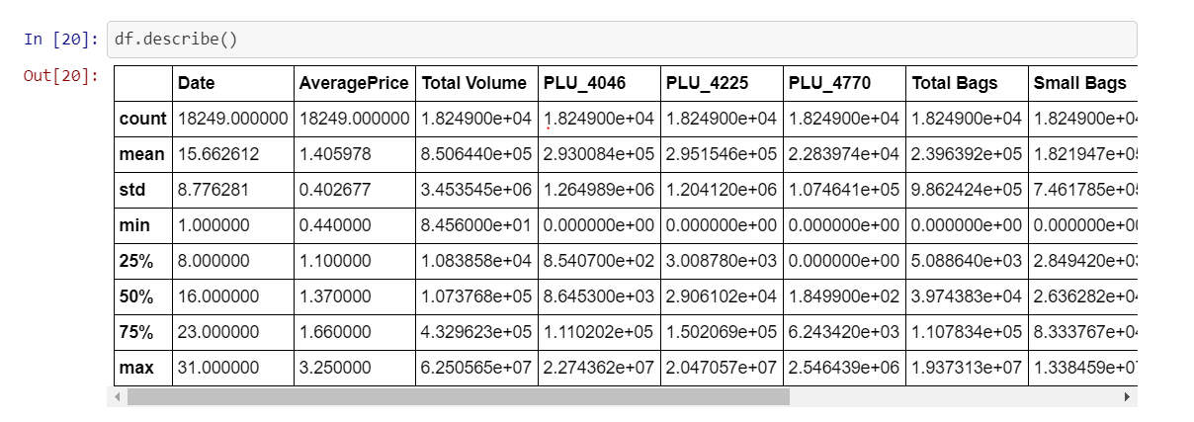

Fig 7

Above statistics data show that their multiple outliers mostly in XLargeBags There is also difference between mean and 50% value in some of the columns which used to get fix for better prediction

* Also, number of rows in each column are same, means there are no null values in the data set.
* Also, the mean and 50%value of most of the column are same and the STD and mean are very close to each other.
* Most of the column statistics data are near to 0 values.
* By checking the difference between the 75% and max value there are outliers in some of the column, I will check it soon.

**Data Visualization:**

In this portion we can plot different graph using different columns and try to visualize the data using matplotlib and seaborn library.

We use different graph include:

* Bar plot
* Count plot
* Line plot
* Histogram and Pair plot

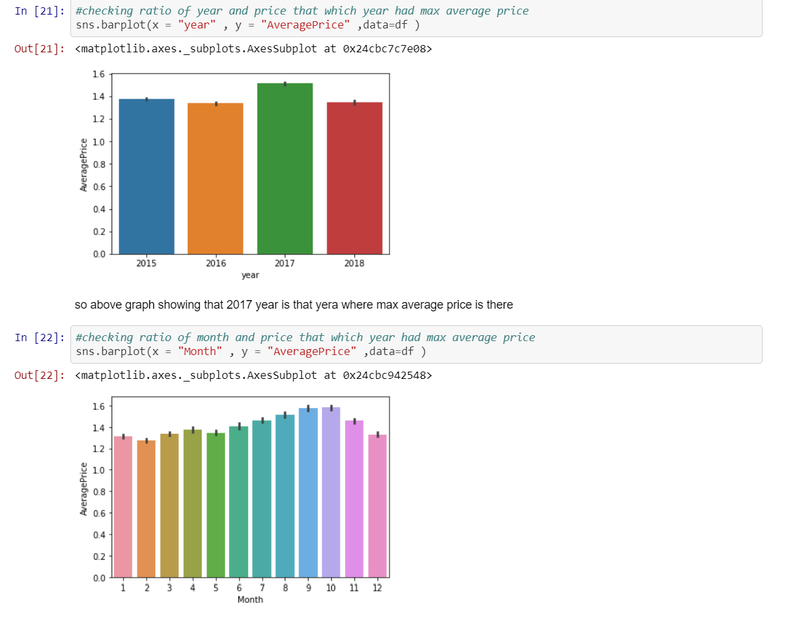

Fig 8

From above we came to know that:

* Year 2017 is that year where the price is maximum as compared to other year, and there is less difference among rest of the year.
* September and October are the month where max no of average price is there, but the thing is almost for whole year the price is almost same for the avocado this prove that there is so much craze of avocado rather than India.

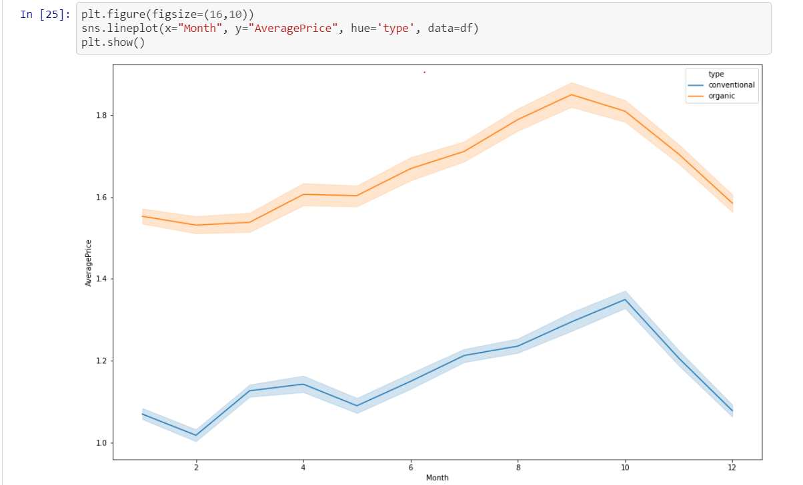

From above graph:

* There is hike between month 8–10 of both type of avocado both for conventional and organic type of avocado.
* Also, the conventional type of avocado is varying in term of price as seen in line plot because in starting the price is high but then it get decrease and so on.

**Plotting Histogram:**

* A **histogram** shows the frequency on the vertical axis and the horizontal axis is another dimension. Usually it has bins, where every bin has a minimum and maximum value. Each bin also has a frequency between x and infinite
* So, in this we can also check whether the graph is right skewed, left skew or the graph is normally distributed graph

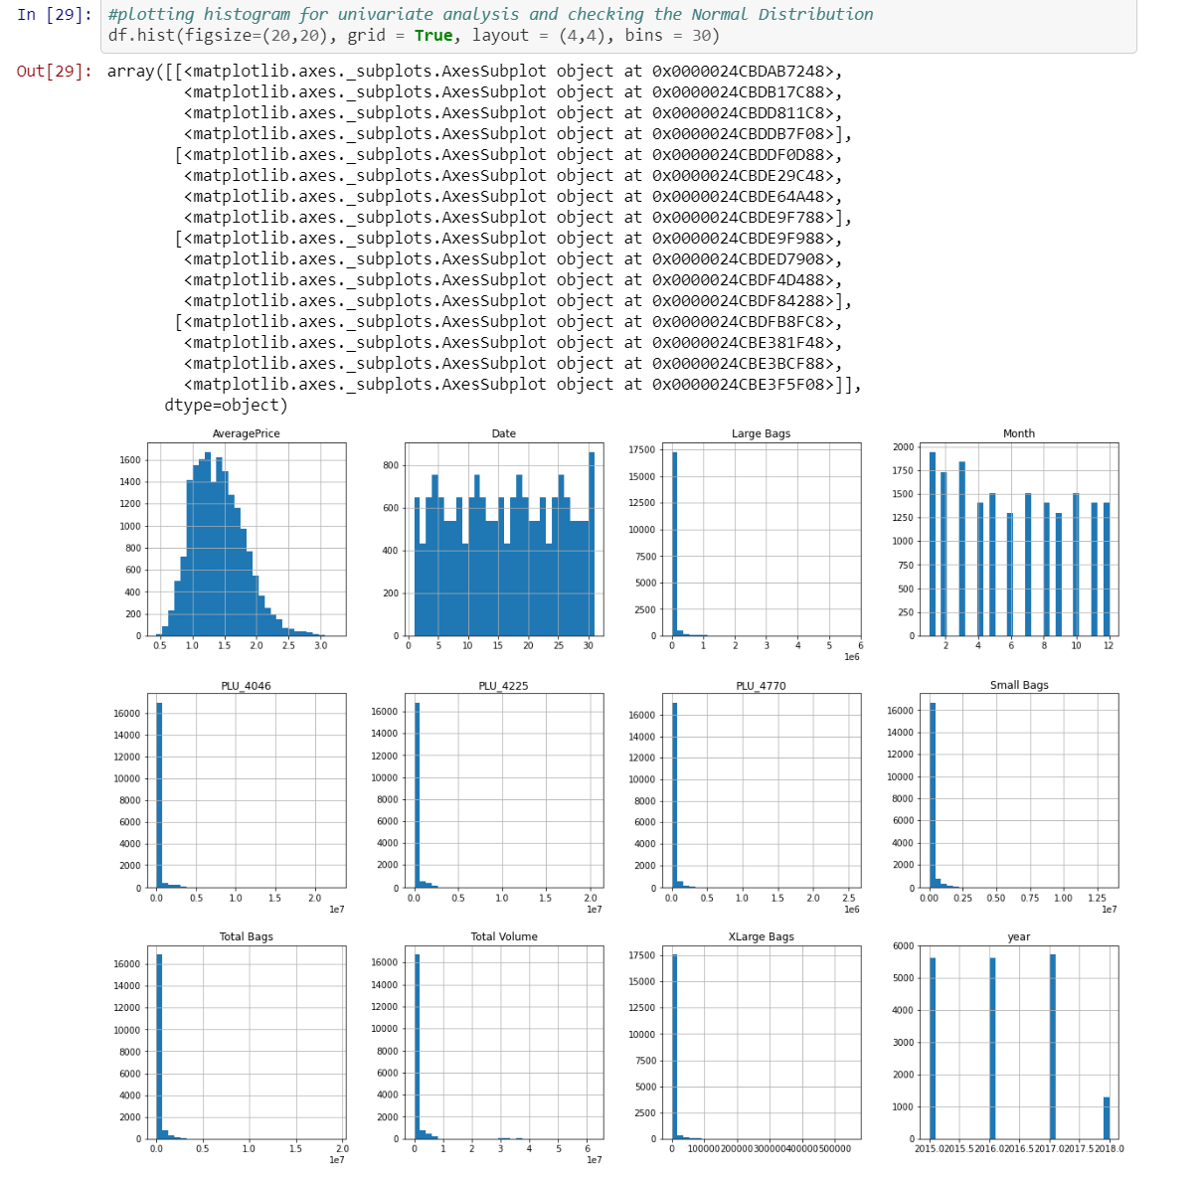

Fig 9

From plotting this histogram, I used the bin size as 30, we can take any bin size (suited as per as data).

* Average price column is normally distributing over the histogram.
* Rest of the data are not much varying in term of numbers, so they are almost left skewed data
* To make the column as normal distributed we can use different methods, but I am using numPy log to make the skew values as normal distributed.

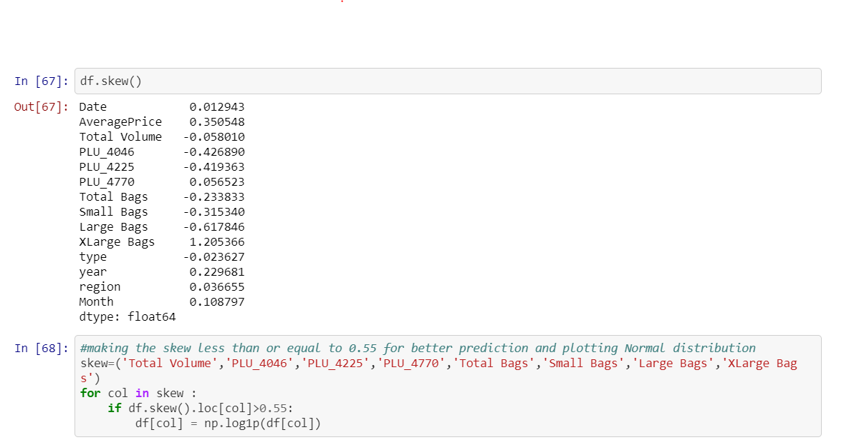

Fig 10

In above image we are first calculating the skew value and some of the column skew value are far from zero.

* The best skew value for normally distributes is very close to zero, so we are using “log1p” method to make the skew value near to zero
* In the last cell I am again checking the skewness value and there is difference between the first skewness value and second, now the skewness value of each column is near to zero.

Note: Making the skewness value near to zero will help to get better score.

**Label Encoding:**

Sklearn provides a very efficient tool for **encoding** the levels of categorical features into numeric values. **Label Encoder encode labels** with a value between 0 and n_classes-1 where n is the number of distinct **labels**. If a **label** repeats it assigns the same value to as assigned earlier

Convert Region and Type into numeric value by using encoder.

**Outliers:**

An **outlier** is a data point in a data set that is distant from all other observations. A data point that lies outside the overall distribution of the data set.

Now that we know outliers can either be a mistake or just variance, how would you decide if they are important or not. Well, it is simple if they are the result of a mistake, then we can ignore them, but if it is just a variance in the data, we would need think a bit further.

For avocado problem first check the outliers of each column.

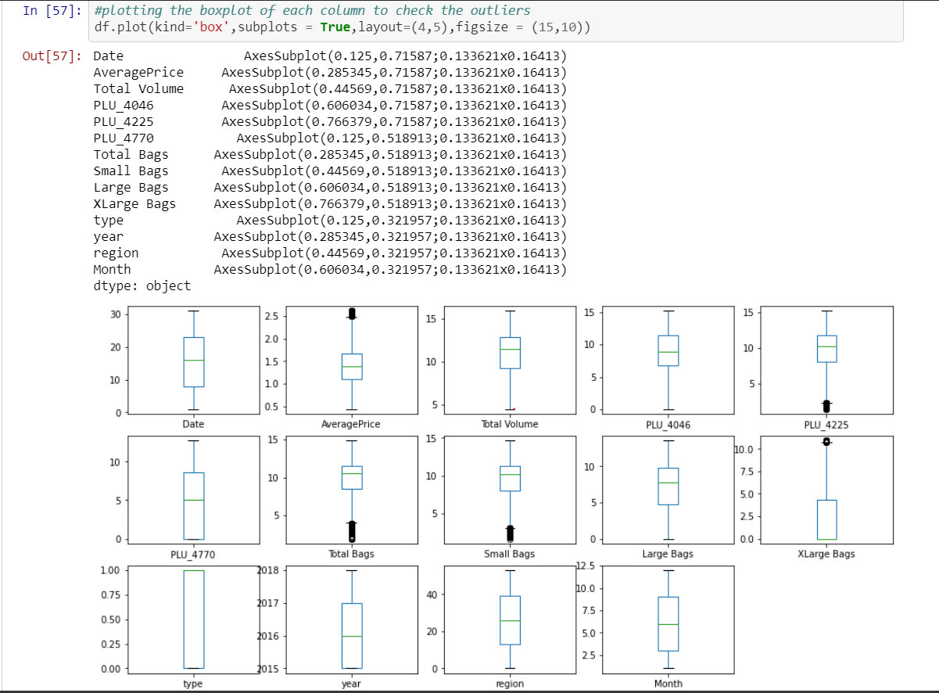

Fig 12

From above image we can clear see that there are number of black dots in most of the column which are referring to the outliers, so it means most of the data are outside the distribution.

So now we detect the outliers now the second step is to remove the outliers, there are different way to remove the outliers that are find the IQR, zscore values.

I am using both zscore value then I again check if there are some of the outliers then I will remove it by replacing the outliers with the mean value of that column.

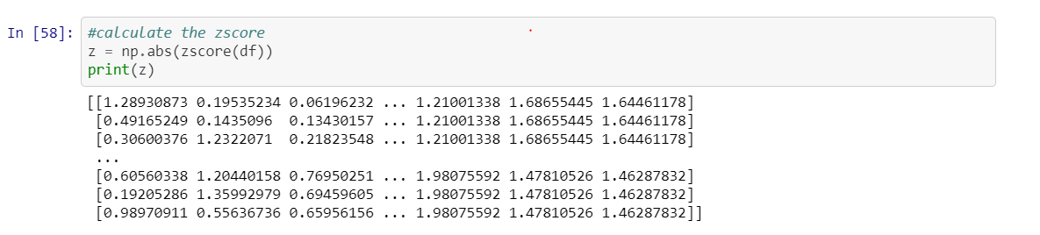

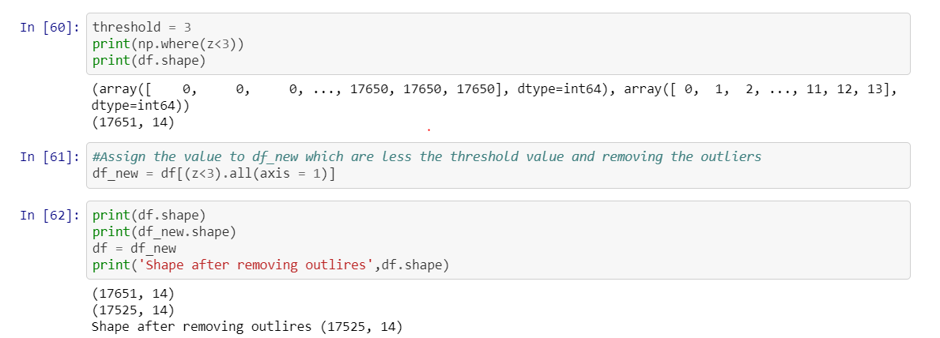

Fig 13

So, I first find the zscore value and then I decide to make one threshold value as 3 which is standard of industry recommend value and then I remove all the outliers which zscore value is greater than 3.

After, removing the outlier’s final there are 17525 and 14 column presents in the data set.

**Correlation Matrix:**

**Correlation** Matrix is basically a covariance matrix. A summary measure called the **correlation** describes the strength of the linear association. **Correlation** summarizes the strength and direction of the linear (straight-line) association between two quantitative variables. Denoted by r, it takes values between -1 and +1.

Now I am finding the correlation value of each column, this value is categorized into mainly 2 parts that are:

- Positive correlated value

- Negative correlated value

The most the value is positive means that column is much co related and vice versa.

I am using seaborn heatmap to plot the correlated matrix and plot the corr value in the heatmap graph

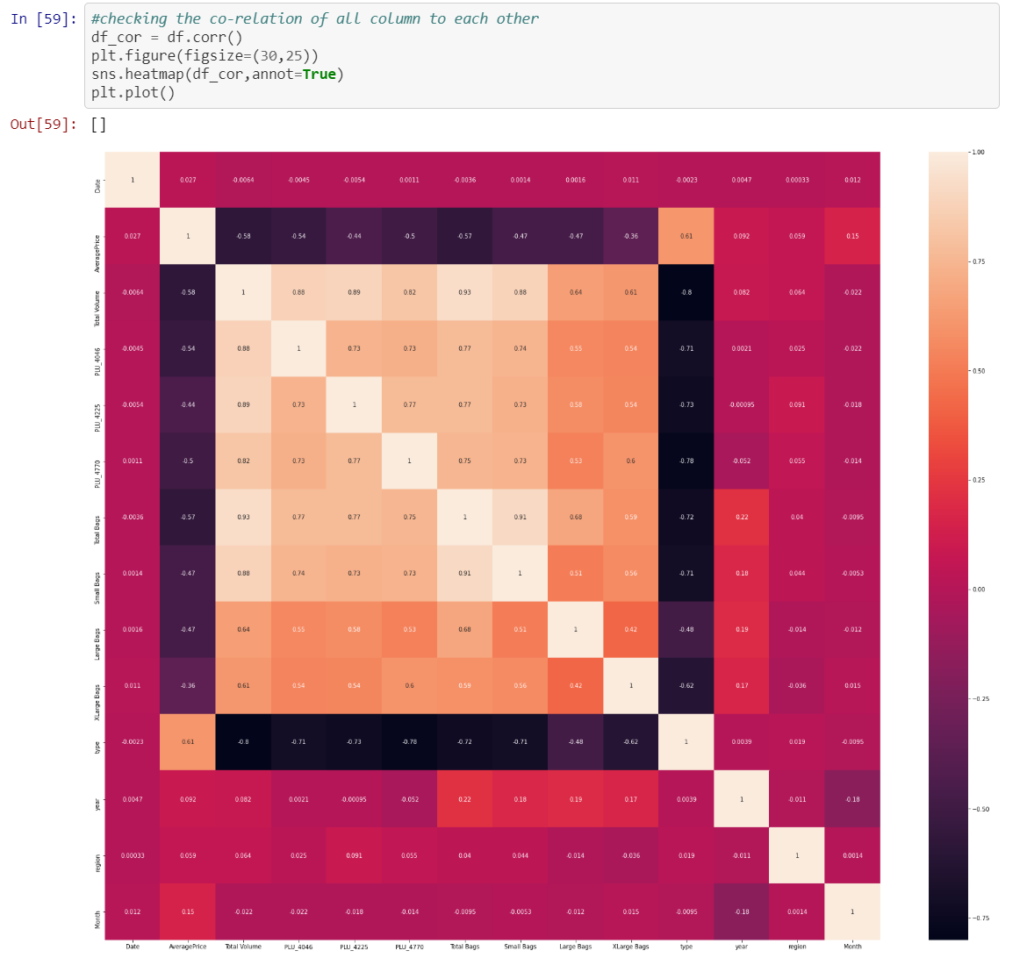

Fig 14

**Drop and Standard Scaler:**

Here I am making two variable x and y where x is having all column except Average Price and Date, we can also drop the Date column, but I kept for EDA purpose and y is having only Rings column.

Also, I am using the standard scaling method on x variable

**Prediction with Average Price:**

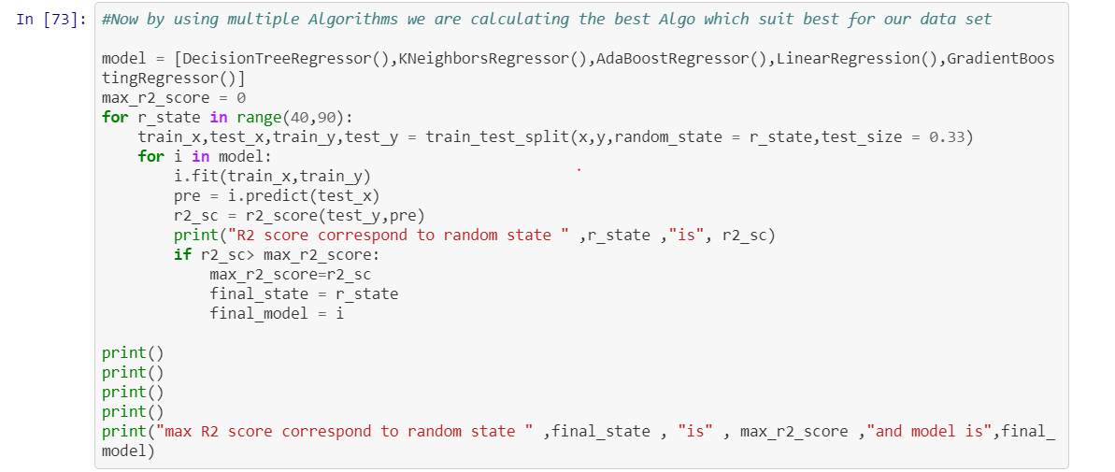

Fig 15

Above I am using the for loop which help me to provide the R2 score at each random state and for the best state where R2 score is maximum is come as output value.

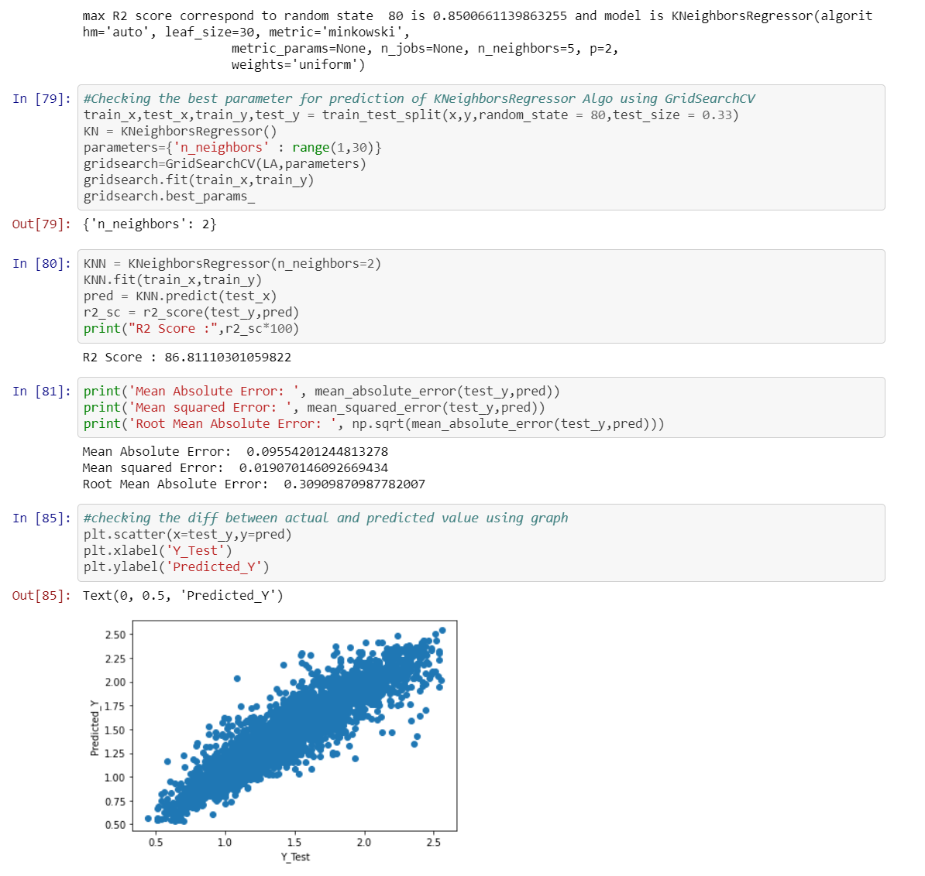

Fig 16

In prediction:

* I had done this prediction by taking Average price as an output variable which is continuity in nature so that why I’m using the regression technique
* While calculating the best random state the 80 is best state which providing the highest R2 score value for this model.
* After using the GridSeachCV, I can find the best param and then I used these param for that model.
* After using the best param I can get the best R2 score and the model is KNeighboursRegressor.
* There are following matrices which I find, and which are providing the best score.
* I also plot the scatter plot graph and we can see that the actual value and predicted values are very close to each other, so the line is best fit line.

Now I am finding the score by taking region as an y value, I am using classification method because the region data is categorical in nature, so I am importing the classification model and their matrices.

**Prediction with Region:**

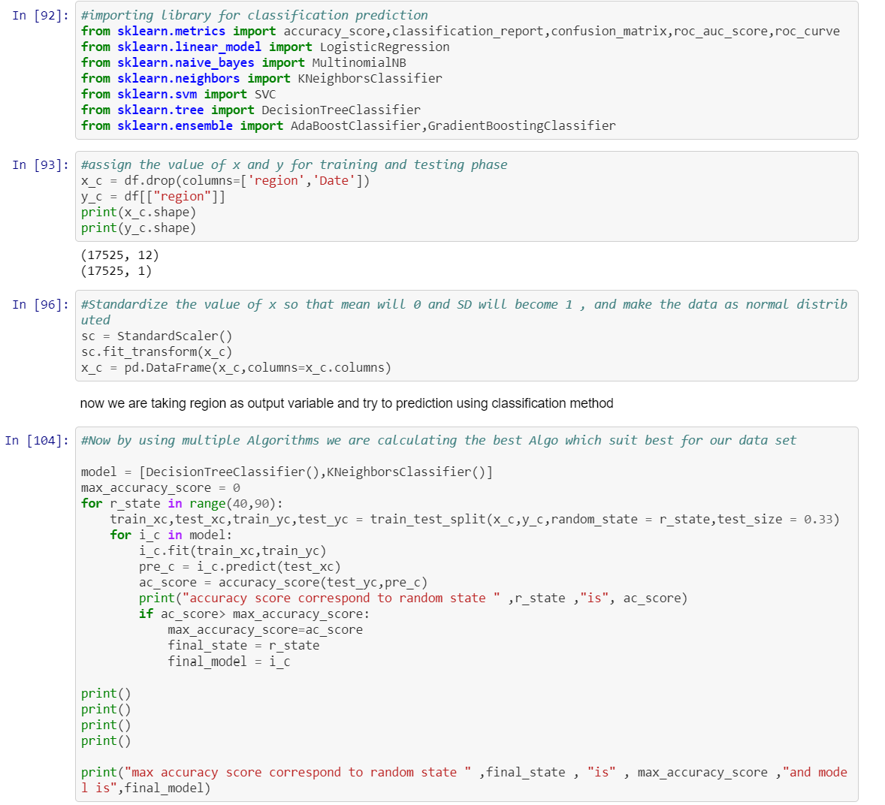

Fig 17

Here I again done the standard scaling and use the same for loop model which provide the best state giving the best accuracy score.

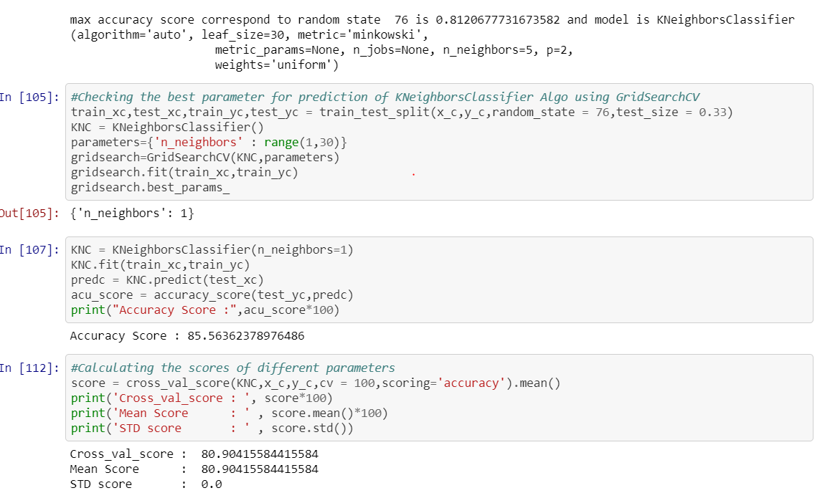

Fig 18

In prediction:

* Here the random state that is occurring is 76 which provide the best accuracy score for the model which is 81%.
* Also, by using the GridSeachCV I am able to find the best param and then find the best accuracy score that is 85%

**Roc Curve:**

It is a plot of the false positive rate (x-axis) versus the true positive rate (y-axis) for a number of different candidate threshold values between 0.0 and 1.0. Put another way, it plots the false alarm rate versus the hit rate.

The true positive rate is calculated as the number of true positives divided by the sum of the number of true positives and the number of false negatives. It describes how good the model is at predicting the positive class when the actual outcome is positive.

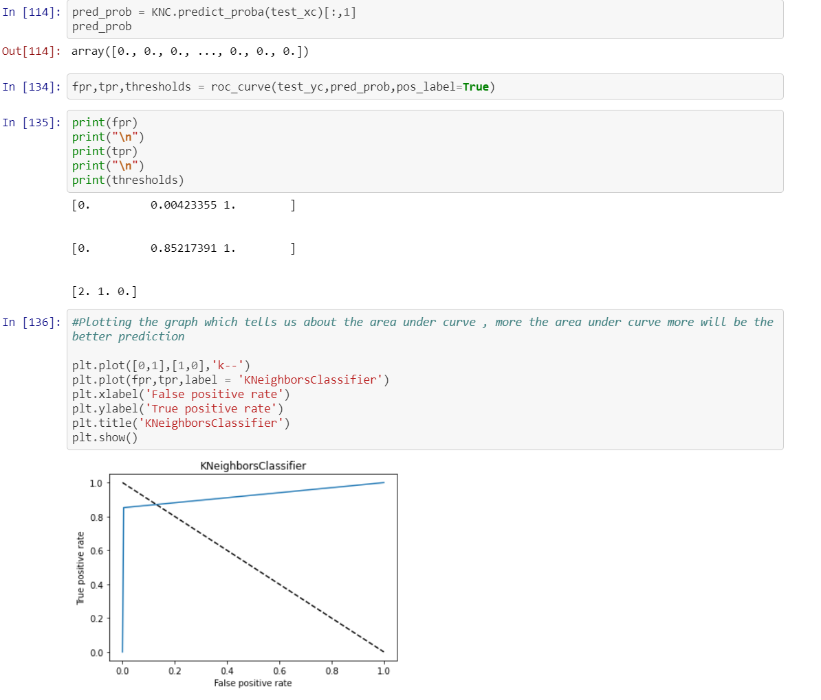

Fig 19

**Observation:**

* Taking price as y variable is predicting well for this model as compare to region
* Also, I used the Label Encoder to make the categorical data into numeric data i.e. Region and Sex
* Also, R2 score value is also greater then accuracy score
* Average price, total bags and total volume is well normally distributed data among all other column
* There are no outliers in the data set after replacing it through mean value
* As year is most negative co related column among all columns
* In between August to October the price of avocado is much higher as compared to other months
* Date 28,29 and 30 the price of avocado is high
* Hartford Springfield, San Francisco and New York are having more average price as compared to another region
* There is hike between month 8-10 of both type of avocado
* As organic type of avocado is having the more price per unit then conventional
* I had done prediction using region and price but using price the prediction score is high as compared to region
* So in this data set I am using both regression and classification technique for making this model